11/8/2024 11:08:30 AM

NAME: Sumayya Nasiru | Age:Ad | Sex:F | Ref No:00010
Clinical Details: USG Pelvic |  |  |  | US:10

REAL TIME PELVIC ULTRASONOGRAPHY EXAM: REVEALED:

URINARY BLADDER:Distended with urine with normal mucosal thickness. No gross masses or stone seen.

UTERUS: The uterus is gravid, containing moderate an echoeic product of conception in the uterine cavity. The anterior and posterior myometrium appears normal. Right and Left adnexia are free.

CUL-DE-SAC: Mild free fluid collection.

IMPRESSION: The USS features are suggestive of Minimal RPOC (Incomplete miscarriage).

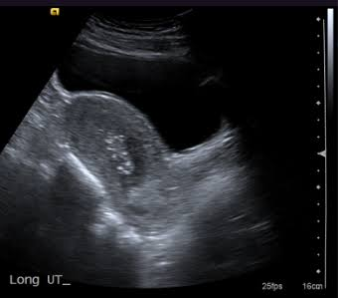

Ultrasound specialist.

